National University of Computer & Emerging Sciences
Karachi Campus



Project Report/Proposal

Redundant Traffic Elimination and In-network Load Balancing at Transport Layer

Course Teacher:
Ms. Erum Shaheen
Ms. Rabia Ansari

Group Members:
Zaid Bin Shahab 19K-1512
Muhammad Ali 19K-0331
Saud Ahmed Abbasi 19K-0229

Abstract:

Manu routing protocols exist, be it old or new, but are essentially used for the same purpose and utility. They serve to ideally select routes between any two nodes on a computer network and disseminate the information. A routing protocol’s job is to specify the method of communicating routers used in the inter-connection of networks. This Project is important in identifying such routing protocols (mainly: RIP, OSPF, and EIGRP), and analyze their methodology of operation. In this project we have simulated and thoroughly analyzed a proposed LAN (Local Area Network) using different routing protocols. The configuration of these different routing protocols is done using CISCO Packet Tracer Simulator.

1. Introduction:

Routing protocols have their own algorithm from protocol to protocol and have performance differences. There are 3 typical types of routing protocols that are simulated in this Project, namely RIP, OSPF and EIGRP.
RIP (Routing Information Protocol) is the oldest routing protocol in service, it uses hop count as the metric for routing, and hop limit limits the network size that RIP can support.
OSPF (Open Shortest Path First) is the most widely used IOSPF based on the SPF (Shortest Path First) algorithm which is used to calculate the shortest path to each node.
EIGRP (Enhanced Interior Gateway Routing Protocol) is Cisco’s proprietary routing protocol which uses Diffusing Update Algorithm.

Routing protocols are the language routers speak when communicating with other routers in order to share information about the status and reachability of a network. It is a procedure which selects the best path based on the reachability information and records this information in a route table. A routing metric is computed by a routing algorithm in order to select the best path.

Metric is a variable assigned to routers by which they are ranked from best to worst or on the basis of preference. Different routing protocols have different metrics. Metrics must be calculated using a routing protocol when there is more than one route between two nodes.

2. Classifying Routing Protocols:

Interior Gateway Protocol (IGP) is best used for routers operating in the same domain network such as Routing Information Protocol (RIP), Enhanced Interior Gateway Routing Protocol (EIGRP), Open Shortest Path First (OSPF) and ISIS (Intermediate System- Intermediate System). In different domain networks, Exterior Gateway Protocol (EGP) is used as the Border Gateway Protocol (EGP). Within the same network, two types of dynamic routing protocols can be used, namely link routing and distance vector protocols.

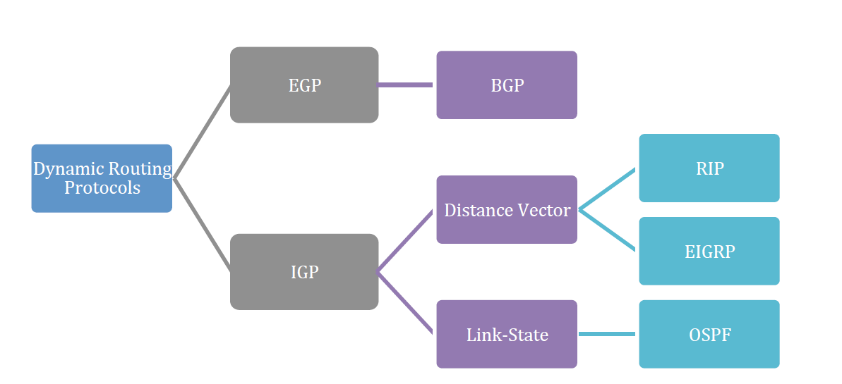

2.1 Distance Vector Protocols

Distance vector refers to characteristics of advertised routes: Distance – how far it is to the destination network based on a metric (such as hope count, bandwidth, delay, cost). Vector – Specifies direction taken by the next-hop router or exit interface in order to reach a destination. Example: RIPv1 (legacy), RIPv2, IGRP Cisco proprietary (obsolete), EIGRP.

2.1.1 Routing Information Protocol (RIP)

RIP is a distance-vector routing protocol based on Bellman-Ford algorithm; it uses hops as a routing metric. Routing updates broadcast 255.255.255.255 every 30 seconds. The metric used is hop count, maximum number of allowed hops is 15, this limits the size of networks supported by RIP. RIPv2 is a classless routing protocol that supports CIDR and VLSM. It has increased efficiency and sends updates to multicast address 244.0.0.9. The reduction in routing supports manual route summarization and allows secure supports authentication.

2.1.2 Enhanced Interior-Gateway Routing Protocol (EIGRP)

EIGRP successfully replaced IGRP in 1992. The following features are included:
Bounded Triggered Updates – Sends updates to only the routers that need them.
“Hello keepalive” mechanism – Hello messages are exchanged periodically to maintain adjacencies.
Topology table regularly maintained – Maintains all the routes received from neighbors (even the paths that are not the best) in a topology table.
Rapid Convergence – As it maintains alternate routes.
Multiple network layer protocol support – Utilizes Protocol Dependent Module (PDM) which supports 3 protocols.

2.2 Link-State Routing Protocol

Link-state routers utilize the link-state information they receive from other routers: used to create a topology map to help select the most optimum path to all destination networks in the topology.
Link-state routing protocols do not make use of periodic updates. Updates are only sent when there is a change made to the topology.
Both of the following Interior Gateway Algorithms (OSPF and IS-IS) are based on the Dijkstra algorithm.

2.2.1 Shortest Path First Protocols (OSPF)

Link-state routing protocols, alternatively known as first protocols, are built around the Djikstra’s shortest path first (SPF) algorithm. IPv4 Link-state routing protocols include:
A. Open shortest Path First (OSPF)
B. Intermediate System-to-Intermediate System Djikstra’s Algorithm, all link-state protocols are in effect
Djikstra uses:
A. Accumulated costs across each path, from source to destination
B. Each individual router determines cost to each destination within the topology.

2.3 Routing Protocol Metrics

Metrics are measurable values that are assigned by the routing protocol to different routes, based on the usefulness of that route. They are used to determine overall cost of a path from source to destination, the best path is with the least cost. Metrics utilized by various dynamic protocols include:
- Rip – Hop Count
- OSPF – Cost based on cumulative bandwidth
- EIGRP – Bandwidth, load, delay and reliability

2.4 Routing Protocol Characteristics

3. COMPARATIVE STUDY OF RIP, OSPF & EIGRP

Protocols Comparison
Feature | RIP- V1 | RIP- V2 | OSPF | EIGRP
Type | Distance Vector | Distance Vector | Link State | Hybrid
Algorithm | Bellmanford | Bellmanford | Dijkstra | DUAL
Class full/ Classless | Class full | Class less | Classless | Classless
Metric | Hop Count | Hop Count | Cost | Bandwidth/ Delay
Timers Update (Hello/Dead) | 30 sec | 30 sec | Triggered when network charge occurs, send periodic update LSA refreshes every 30 minutes | Triggered (LAN3/15,WAN 60/180)
Administrative Distance | 120 | 120 | 110 | Internal 90 External 170
Authentication | No | Yes | MD5 Authentication | MD5 Authentication
Hop Limit | 15 | 15 | 224 | None
Convergence | Slow | Slow | Fast | Very Fast
Type of Updates | Full table | Full table | Only Changes | Only Changes
Support VLSM | No | Yes | Yes | Yes
Network Size | Small | Small | Large | Large
Split Horizon Sensitive | No | No - | Yes | Yes
Area Types | - | - | Backbone, stubby, Not so-stubby, totally stubbing | -

4. Project Working:

OSPF Practice Layout:
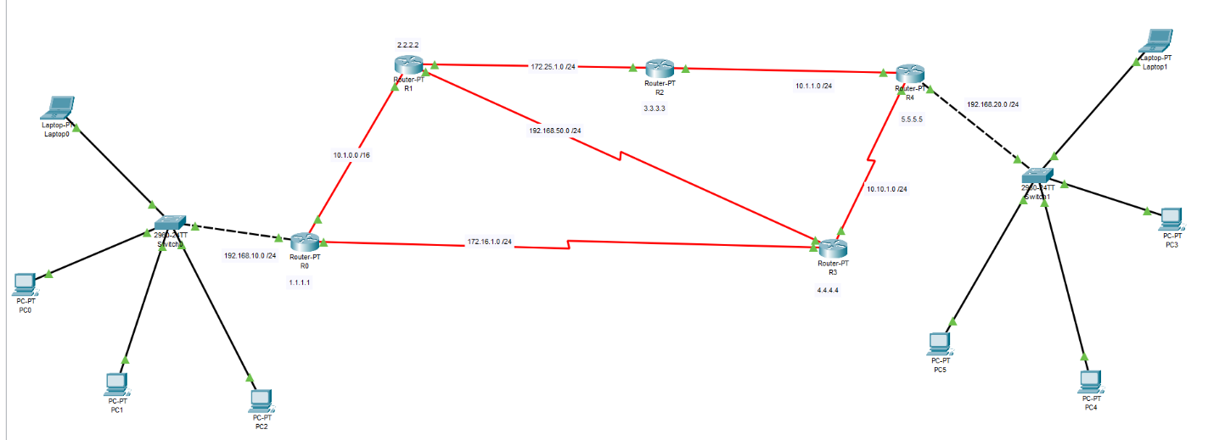
RIP Practice Layout:
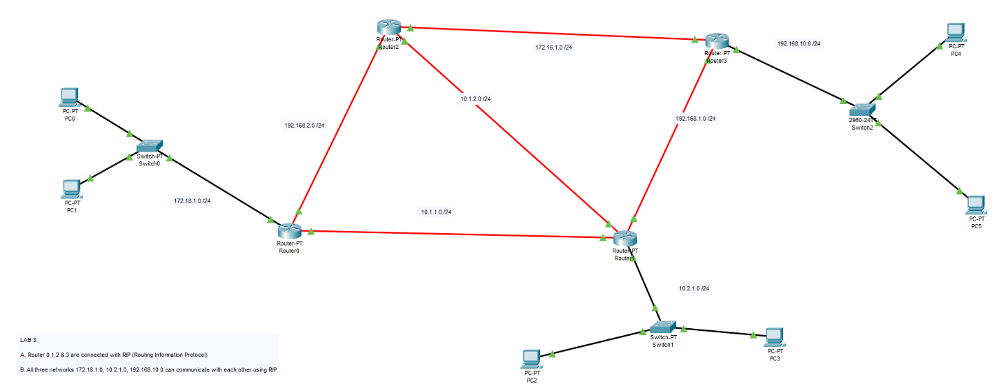

IP Layout for Project:
IT DEPARTMENT (192.168.1.0)
HOD CABIN | 192.168.1.2
IT LAB 1 | 192.168.1.3
IT LAB 2 | 192.168.1.4
IT LAB 3 | 192.168.1.5
IT LAB 4 | 192.168.1.6
Printer 0 | 192.168.1.7

COMPUTER DEPARTMENT (192.168.2.0)
CS HOD CABIN | 192.168.2.2
CS LAB 1 | 192.168.2.3
CS LAB 2 | 192.168.2.4
CS LAB 3 | 192.168.2.5
CS LAB 4 | 192.168.2.6
Printer 7 | 192.168.2.7

OTHERS (192.168.3.0)
OFFICE | 192.168.3.2
Printer 2 | 192.168.3.6
EXAM CELL | 192.168.3.3
Printer 3 | 192.168.3.7
ENQUIRY | 192.168.3.4
TPO | 192.168.3.5
Printer 4 | 192.168.3.8

SERVER ROOM (1.0.0.0)
FTP SERVER | 1.0.0.4
PC1 | 1.0.0.5
DNS SERVER | 1.0.0.2
WEB SERVER | 1.0.0.3

INTERNET LAB (128.168.0.0)
PC2 | 128.168.0.2
PC3 | 128.168.0.3
PC4 | 128.168.0.4
PC5 | 128.168.0.5
Printer 5 | 128.168.0.6

PRINCIPLE ROOM (192.168.4.0)
PC 0 | 192.168.4.2
LAPTOP 0 | 192.168.4.3

Project College Layout:
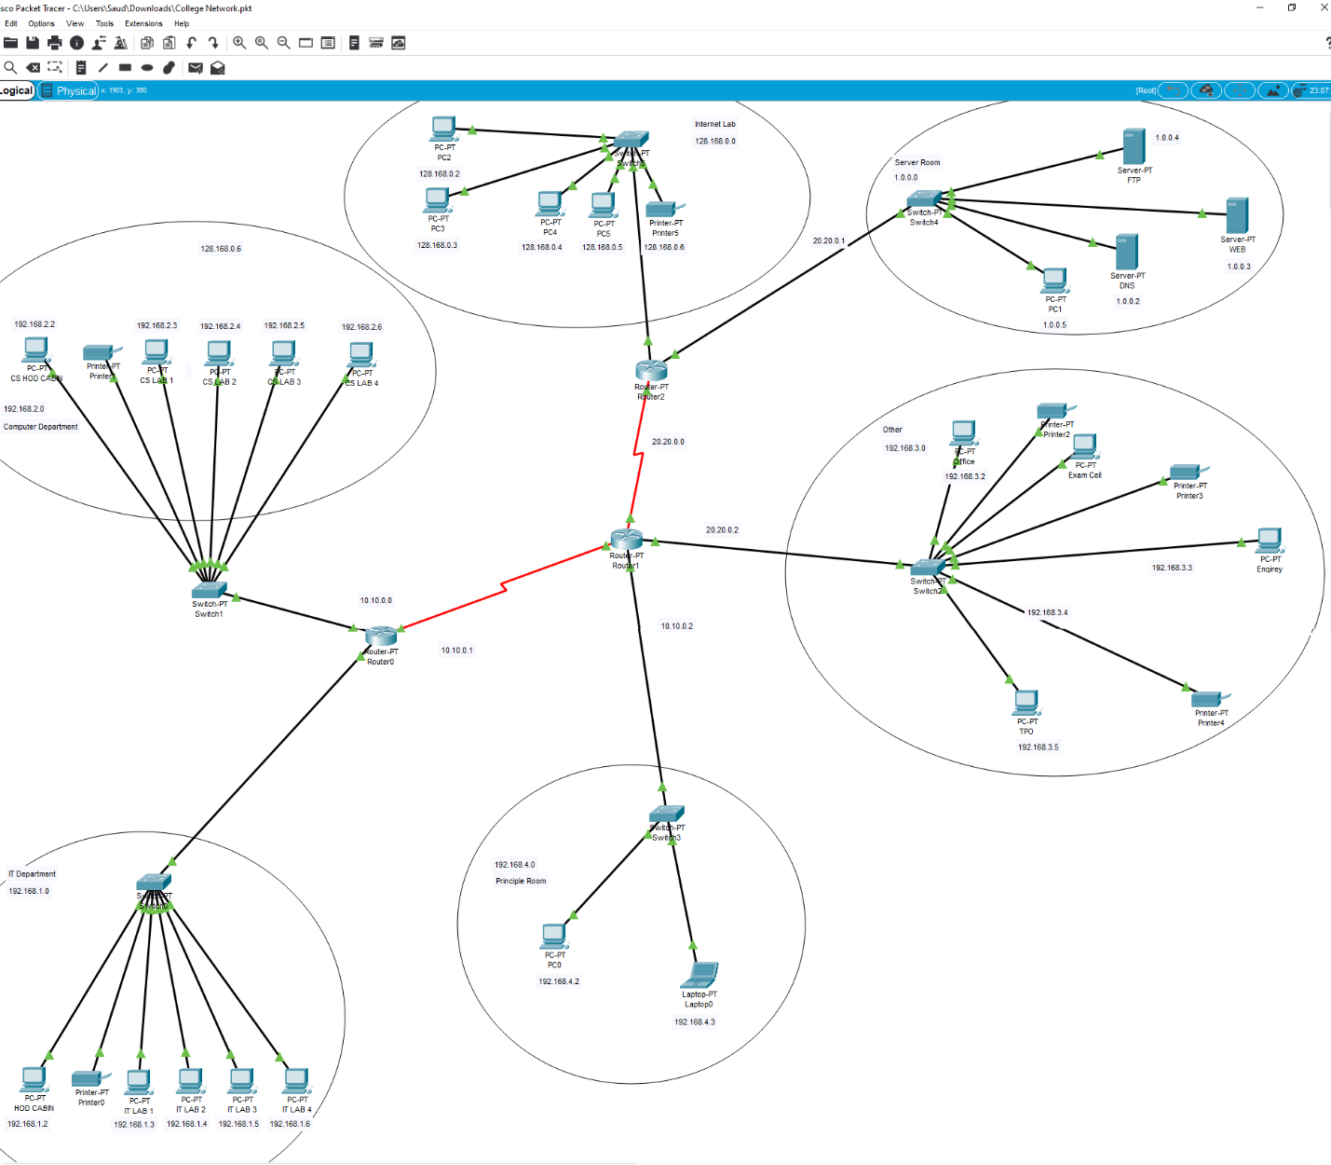
Accessing web page with the HOD Cabin:
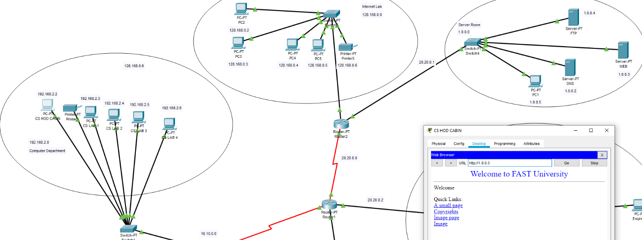

Router#0 Routing Protocol:
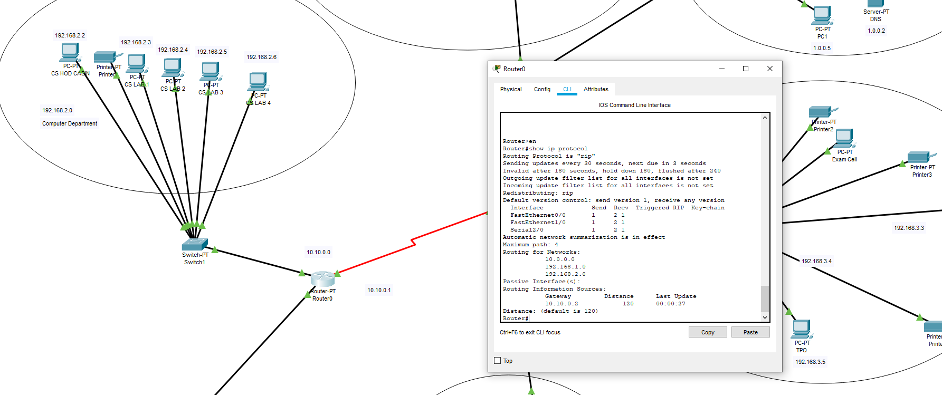
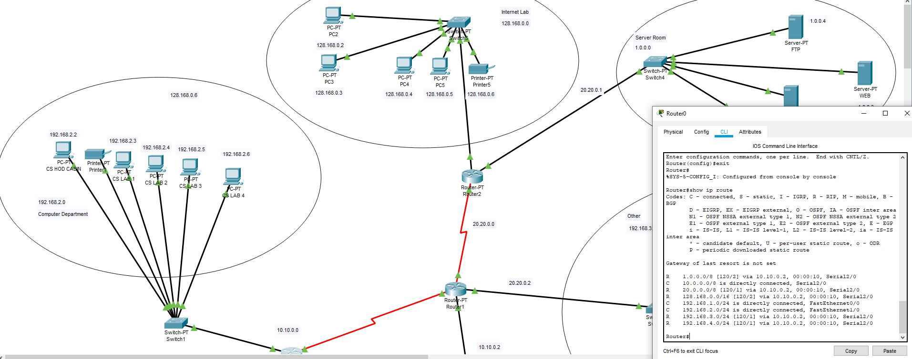

Router#1 Routing Protocol:
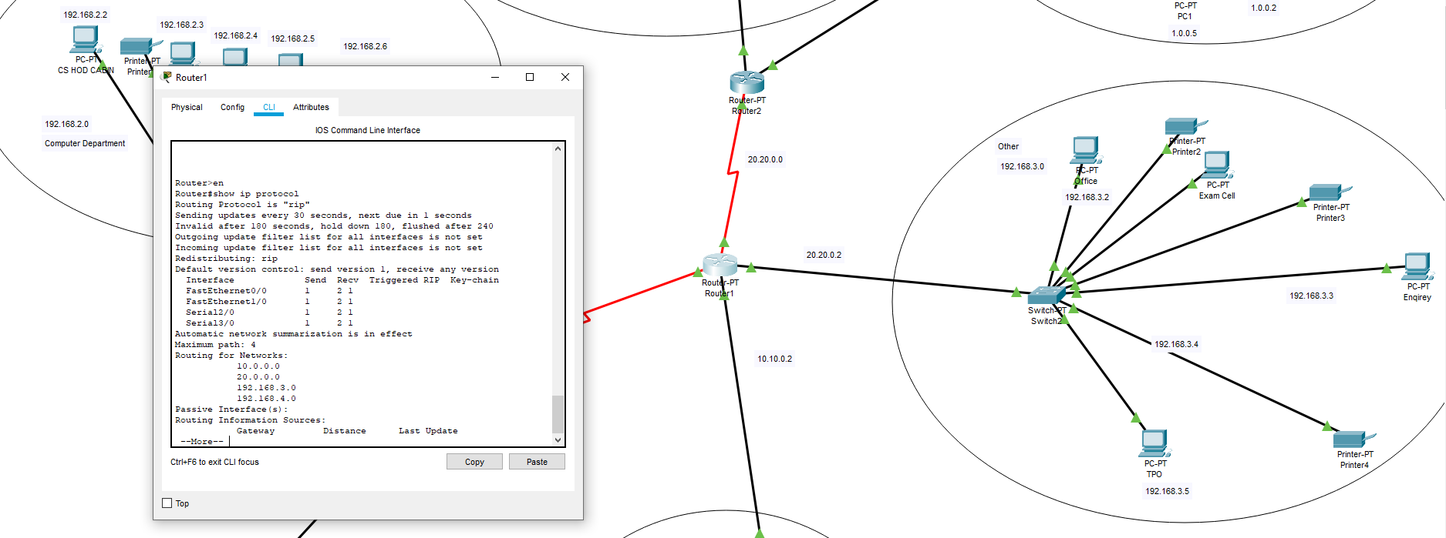
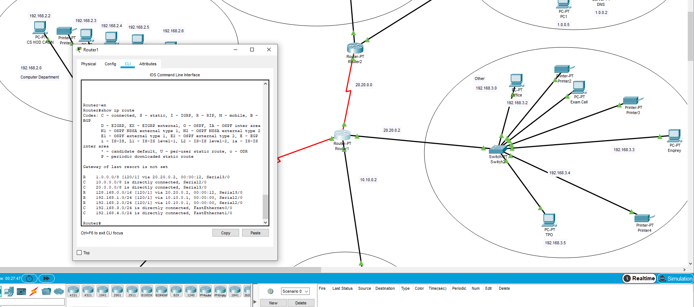
Router#3 Routing Protocol:
